GNSS L1 Transmitter Simulation Using Gold Codes in SystemView

NAME: GIRINATH NU

DURATION: 29/05/25 to 15/06/25

# Table of Contents:

1. Introduction
2. GNSS Signal Structure Overview
3. Gold Code and PRN Generation
4. Simulation Setup in SystemView
5. Conclusion
6. References

## Introduction:

GNSS, or Global Navigation Satellite System, refers to a constellation of satellites that provide autonomous geo-spatial positioning with global coverage. It's essentially a system that allows devices to determine their location on Earth using signals from these satellites. The most well-known example of a GNSS is the US's GPS (Global Positioning System), but other systems like Russia's GLONASS, Europe's Galileo, and China's BeiDou also fall under the umbrella of GNSS.

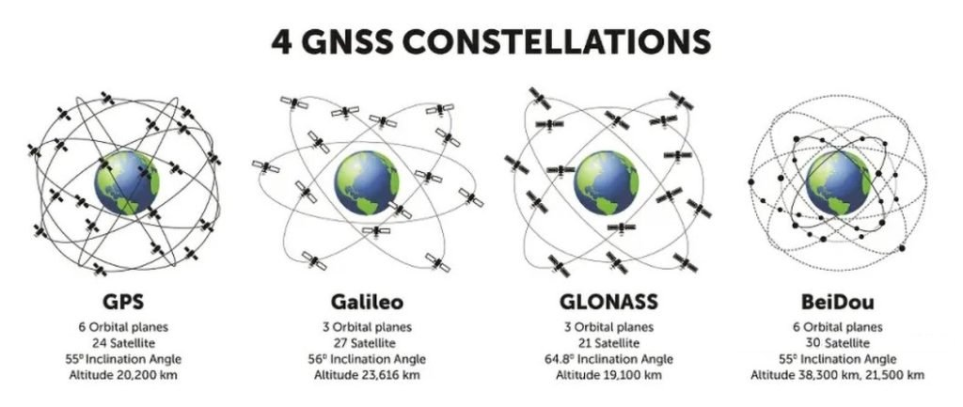

Figure : 4 GNSS Constellation

SystemVue is a powerful EDA software that streamlines the design process for complex communication systems by providing a comprehensive environment for modeling, simulation, and verification across multiple domains, with a strong focus on the physical layer. In this report I have explained in detail how I simulated the Gold Code generation & GNSS Transmitter in SystemVue software.

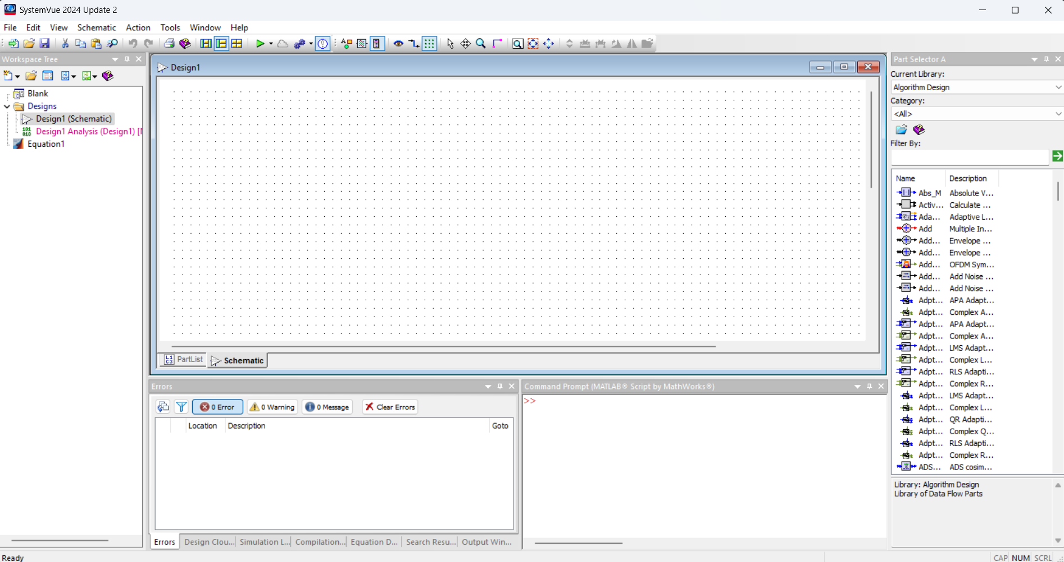

Figure SystemVue Software

## GNSS Signal Structure Overview:

GPS signal consists of two carrier waves ((L1 = 1575.42 MHz or 19 cm and L2 =1227.60 MHz or 24.4 cm), two or more digital codes (Coarse Acquisition code or C/A on L1 and P-code on both L1 and L2), and a navigation message. Civilians have access to C/A code on L1 only. P-code is encrypted with an unknown W-code resulting in a Y-code [i.e., P (Y)] and is not available to civilians (for military purpose only). This is called antispoofing. Use of P-code can provide very accurate estimation of position (precise positioning service, PPS) as ionospheric distortion can be completely eliminated using L1 and L2 signals. However, use of C/A code only cannot provide very accurate estimation of position (standard positioning service, SPS). The newer satellites transmit two additional codes (L2 CM – civilian moderate and L2 CL –civilian long). These additional codes will be helpful in minimizing errors due to atmospheric effects. The navigational message contains information about almanac, ephemeris, clock correction, satellite health, atmospheric correction etc. This is added to both C/A and P-Code. These codes contain information about the satellite identity (PRN) and timing information. These codes are then added on to L1 (both C/A and P codes) and L2 (P-code only). Figure 3 is a schematic diagram of the GPS signal.

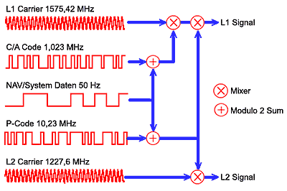

Figure Composition of the signals from GPS satellites

## Gold Code and PRN Generation:

PRN code has essential roles in GPS signals. This PRN code is generated following a specific procedure proposed by Gold [4,5]. Hence, the PRN code is also known as Gold code. Beside spread spectrum functionality of PRN code, this code also used to identify which satellite a received GPS signal comes from. That is, PRN code is also used to identify the satellite number (satellite id). Each GPS satellite has a unique PRN code that is generated following the Gold procedure. Figure 4 below shows the procedure to generate PRN C/A code for GPS L1. Note that “+” symbol in Figure 4 isa modulo 2 sum operation.

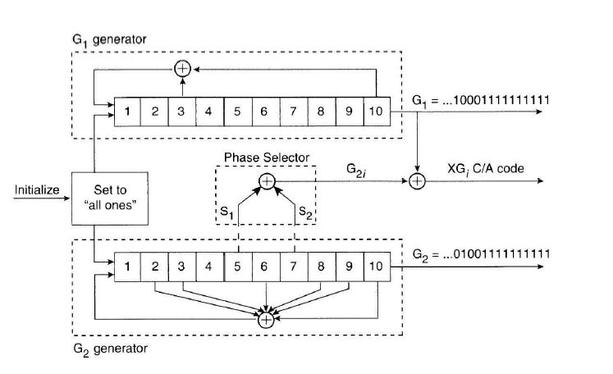

Figure The procedure to generate GPS C/A PRN code. There are a total of 37 types of PRN code to

differentiate the satellite number of the GPS signals

In Figure 4 above, the generator of C/A PRN code (gold code) consists of two register, called G1 and G2. Each shift register has 10 states. From these two register G1 and G2 with 10 states each, a code sequence of 1023 length of code is generated. The G1 and G2 are modulo 2 summed together to generate the 1023 length of code. Every 1023 period, both G1 and G2 are reset to have all 1 value so that the PRN code is repeated (start over again from the beginning).

The polynomial feedback configuration of G1 is:

The polynomial feedback configuration of G2 is:

G1 directly supplied its register output. However, G2 supplies two of its states to another modulo-2 adder (phase selections) to produce the output of G2. This special selection of states of the modulo-2 operation of the two outputs of G2 (before combined with the output of G1) is presented in table 1. In table 1, the phase selection is presented to generate a unique C/A PRN code for each GPS satellite. Also, in table 1, only 32 PRN codes are used for satellites, the other 5 PRN codes are used for ground transmitters.

|  |  |  |
| --- | --- | --- |
| Satellite ID number | PRN Code number | Code phase selection for G2 |
| 1 | **1** | **2+6** |
| 2 | **2** | **3+7** |
| 3 | **3** | **4+8** |
| 4 | **4** | **5+9** |
| 5 | **5** | **1+9** |
| 6 | **6** | **2+10** |
| 7 | **7** | **1+8** |
| 8 | **8** | **2+9** |
| 9 | **9** | **3+10** |
| 10 | **10** | **2+3** |
| 11 | **11** | **3+4** |
| 12 | **12** | **5+6** |
| 13 | **13** | **6+7** |
| 14 | **14** | **7+8** |
| 15 | **15** | **8+9** |
| 16 | **16** | **9+10** |
| 17 | **17** | **1+4** |
| 18 | **18** | **2+5** |
| 19 | **19** | **3+6** |
| 20 | **20** | **4+7** |
| 21 | **21** | **5+8** |
| 22 | **22** | **6+9** |
| 23 | **23** | **1+3** |
| 24 | **24** | **4+6** |
| 25 | **25** | **5+7** |
| 26 | **26** | **6+8** |
| 27 | **27** | **7+9** |
| 28 | **28** | **8+10** |
| 29 | **29** | **1+6** |
| 30 | **30** | **2+7** |
| 31 | **31** | **3+8** |
| 32 | **32** | **4+9** |
| - | **33** | **5+10** |
| - | **34** | **4+10** |
| - | **35** | **1+7** |
| - | **36** | **2+8** |
| - | **37** | **4+10** |

In general, a shift register is a set of one bit storage (memory cells). The content of each register will shift one bit to the right when a clock pulse applied. The output is the content of the last cell (the left most cell or register). For G1, on each clock pulse, the taps at register position 3 and 10 are modulo-2 summed and the results is shifted to register position 1. And, the other registers are shifted one position to the right and finally the content in register position 10 becomes the G1’s output. For G2, on each clock pulse, the taps at register position 2, 3, 6, 7, 8, 9, 10 are modulo-2 summed and the results is shifted to register position 1. Similarly, all other register contents are shifted one bit to the right. Then, depending on the phase selection shown in table 1, these two taps are then modulo-2 summed to be the G2’s output. Finally, the output of G1 and G2 are modulo-2 summed together to produce the PRN code bit on each clock pulse.

## Simulation Setup in SystemVue:

# C/A code simulation setup

## 

Figure : C/A Code generation Schematic in SystemVue

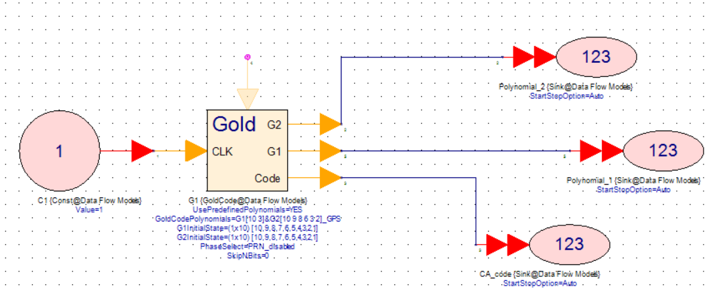

**Const (Constant Generator)**

**Description:**Constant Generator  
**Domain:**Timed

**Model Parameters:** Value, SampleRateOptoion, SampleRate, IntialDelay.

Figure : Constant Generator



**GoldCode**

**Description:**Gold Code Generator **Domain:** Untimed

**Model Parameters:** G1Polynomial, G2Polynomial, GoldCodePolynomial, G1InitialState, G2InitialState, PhaseSelect, SkipNBits.

Figure : Gold Code

**Sink (Data Sink)**

**Description:** Data Sink  
**Domain:** Timed

**Model Parameters:** StartStopOption, SampleStart, SampleStop, TimeStart, TimeStop, SinkTarget, ContinuousMode, Graph, Table,…



Figure : Data Sink

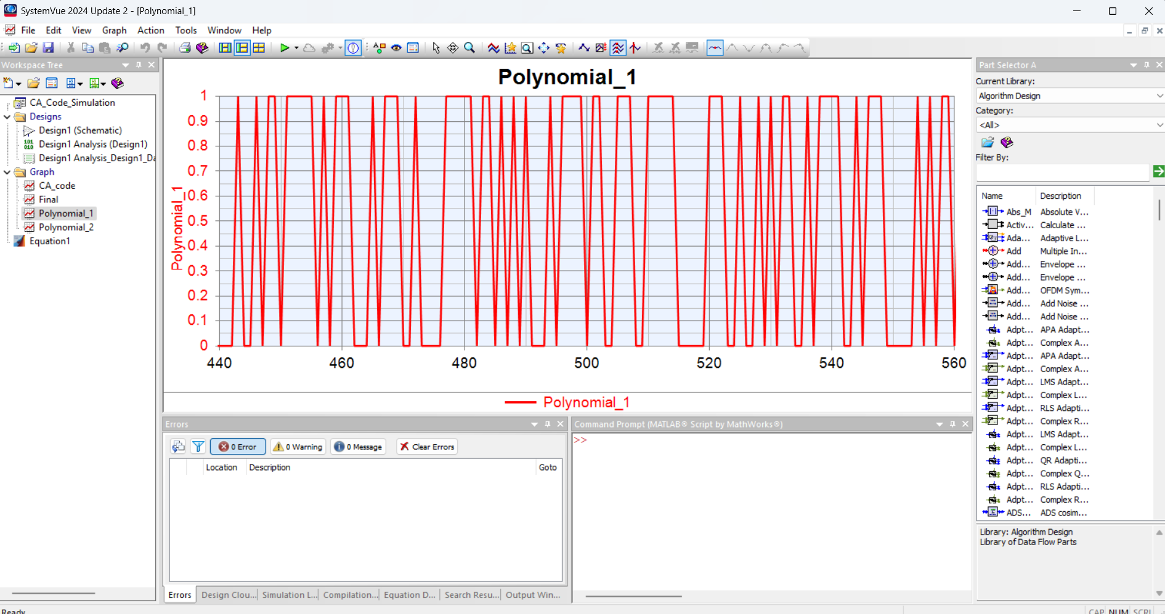

Figure : G1 output is plotted as graph

## 

Figure : G2 output is plotted as graph

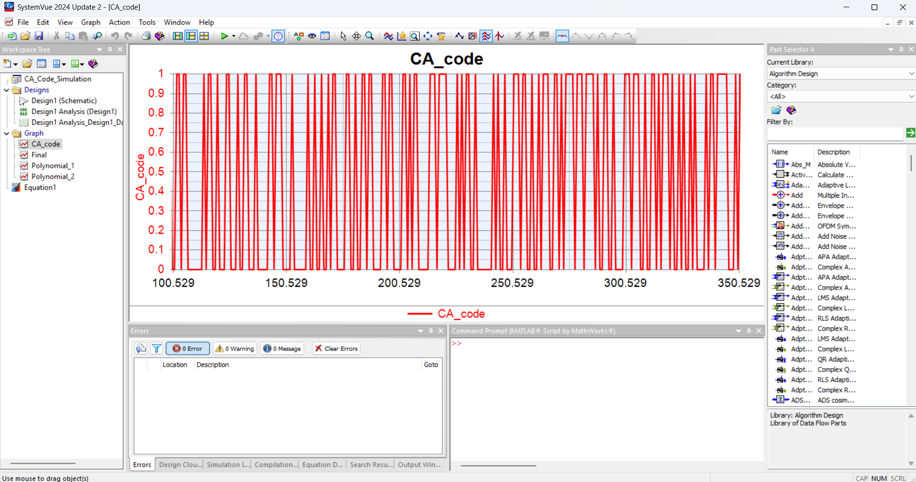

Figure : C/A Code output is plotted as graph

# GNSS Transmitter using C/A Code Simulation Setup

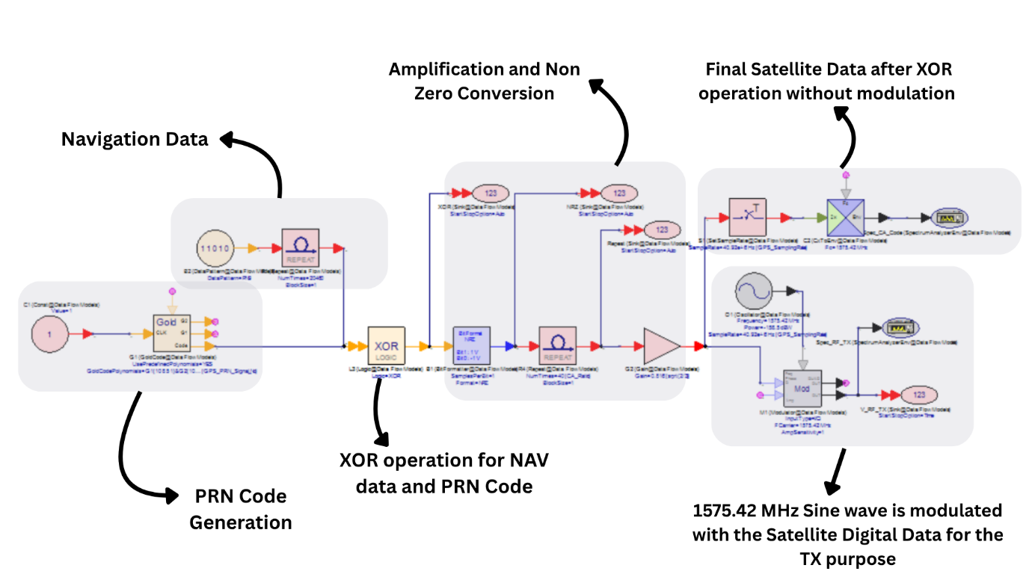

Figure : GNSS TX using C/a=A Code Simulation Setup

Now we will see the graph plotted for each stage and since we saw the graphs for the Gold Code and Navigation Data will be a simple square wave of 50Hz so we’ll graphs after those stages like XOR operation, Amplification and Non-Zero Conversion, After Modulation & without Modulation.

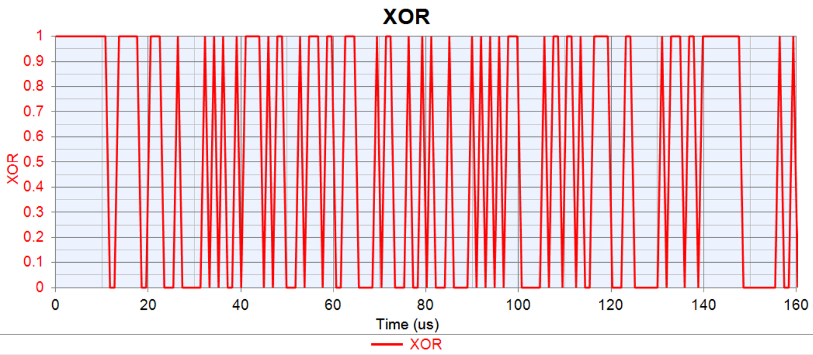

Figure : After XOR Operation of NAV data and PRN code

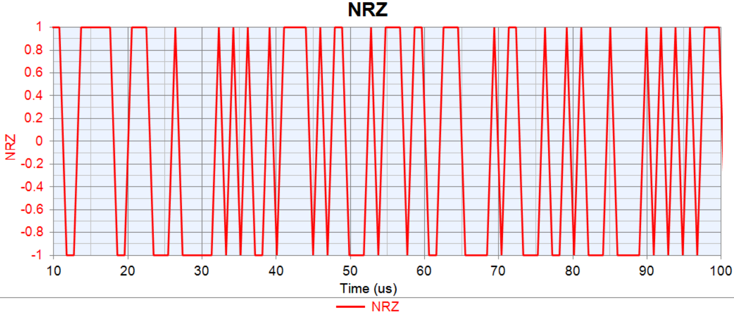

Figure : Non-Return Zero format converter after the XOR operation

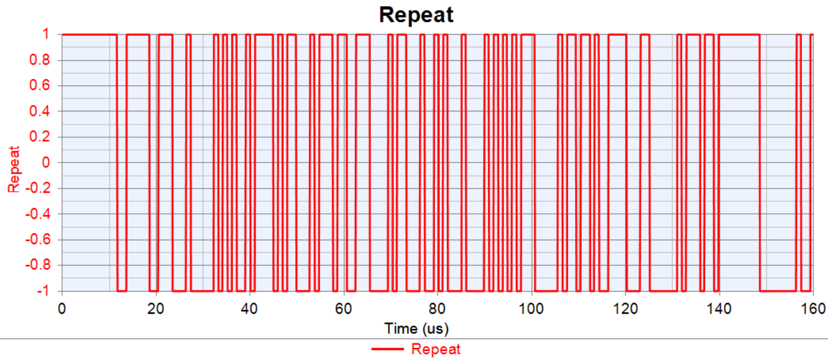

Figure : After repeating the data using repeat block

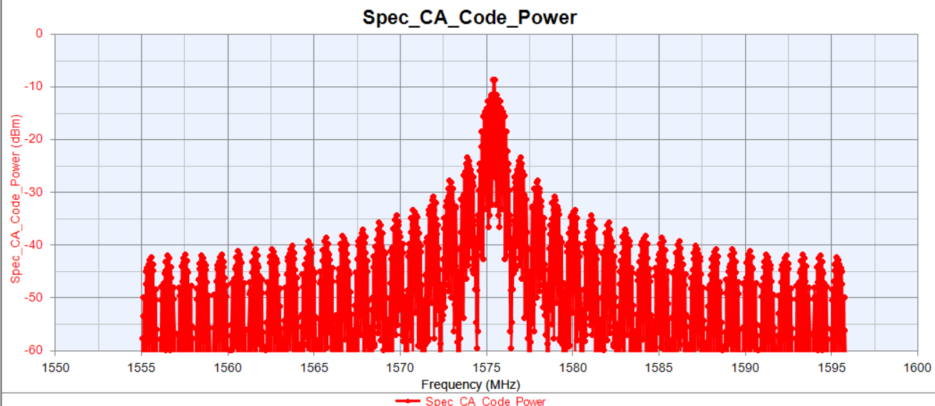

Figure : Frequency Domain of the Transmitting Signal

## Conclusion:

During the course of this internship project, I successfully studied and simulated the core components of a GNSS L1 signal transmitter using SystemView software. This included a detailed exploration of Gold code generation for PRN sequences, understanding their role in satellite signal identification, and the integration of navigation data through XOR operation. The combined signal was then modulated using BPSK and upconverted with a carrier signal, completing the L1 transmission chain. Through this simulation, I gained a comprehensive understanding of how GNSS signals are structured and transmitted. I also developed hands-on experience with using SystemView to model real-world communication systems, and enhanced my practical knowledge in digital modulation, code division techniques, and signal processing. The project helped bridge the gap between theoretical GNSS concepts and their implementation in a simulated environment, laying a strong foundation for future work in satellite communication and signal processing domains.

## References:

1. <https://mettatec.com/how-many-channels-does-a-gnss-receiver-need/>
2. <https://www.researchgate.net/figure/The-GPS-signal-structure-L1-carrier-C-A-code-and-data-message_fig3_269285648>
3. <https://www.intechopen.com/chapters/39780>
4. <https://www.researchgate.net/figure/PRN-code-generation-6_fig2_281652888>
5. <https://youtube.com/playlist?list=PL9OnCetH8TYrdiKM74YXZ8KIxIU1VgK8p&si=-oS1rk06DIcFwh17>
6. <https://youtube.com/playlist?list=PLGvhNIiu1ubyEOJga50LJMzVXtbUq6CPo&si=WjdqBuK1Whn341G->
7. <https://youtube.com/playlist?list=PLX2gX-ftPVXXGdn_8m2HCIJS7CfKMCwol&si=nI5ohoOwJnGSyWI8>
8. <https://www.udemy.com/course/keysight-pathwave-system-design-systemvue-rahsoft-rf-antenna-engineer/?srsltid=AfmBOoorG4aQim8c20-uut4h06tqtbRV5AmNuY0sxmUJbutL8chEKXVw&couponCode=KEEPLEARNING>